Mini Report – Advanced Algorithm for Activities 1.1–1.4

Student Name: Mohamed Hamouda

Student Number: 23077543

Module Code: UFCFYR-15-2

Word Count: 800 words

Table of Contents

1. Introduction 3

2. Degree Calculation 3
2.1 Data Structures 3
2.2 Algorithm Design 3
2.3 Justification 3

3. Password Generator 4
3.1 Data Structures 4
3.2 Algorithm Design 4
3.3 Justification 5

4. Route Planning 5
4.1 Data Structures 5
4.2 Algorithm Design 5
4.3 Justification 5

5. Parallel Programming 7
5.1 Data Structures 7
5.2 Algorithm Design 7
5.3 Justification 7

6. Conclusion 7

7. Reference List 8

1. Introduction

This report outlines the design decisions and algorithms for Activities 1.1 through 1.4. It justifies the chosen data structures and techniques, focusing on optimal space and time complexity, while also highlighting efficiency, scalability, maintainability, and clarity in the implementation of all computational tasks and workflows.

2. Degree Calculation

2.1 Data Structures
The main data structure is dictionaries, storing module information and student marks. They provide constant-time access (O(1)), making lookups efficient and avoiding repeated O(n) searches. Lists enable temporary storage for sorting and calculations, while tuples store fixed pairs like (credits, mark). The CSV module is used to import and export data efficiently (GeeksforGeeks, 2026).

2.2 Algorithm Design
Student marks are processed to calculate weighted averages according to UWE Academic Regulations 23/24. Year 1 checks for pass/fail in each module. Year 2 calculates the best 100 credits by sorting marks in descending order and accumulating until 100 credits are reached, handling varied credit values. Year 3 uses all 120 credits. The 3:1 weighting produces the aggregate. Classification bands determine the degree, and any failed modules result in overall failure. The results are exported in a CSV formatted report (Lee & Hubbard, 2024).

2.3 Justification
Dictionaries enable fast student record retrieval. Lists provide mutability for dynamic reordering when selecting the best 100 credits, allowing in-place O(n log n) sorting. Tuples offer immutability for fixed credit-mark pairs, ensuring memory efficiency and data integrity. As shown in Figure 1, the workflow diagram illustrates the program flow and helps understanding of the algorithm at the start of development.
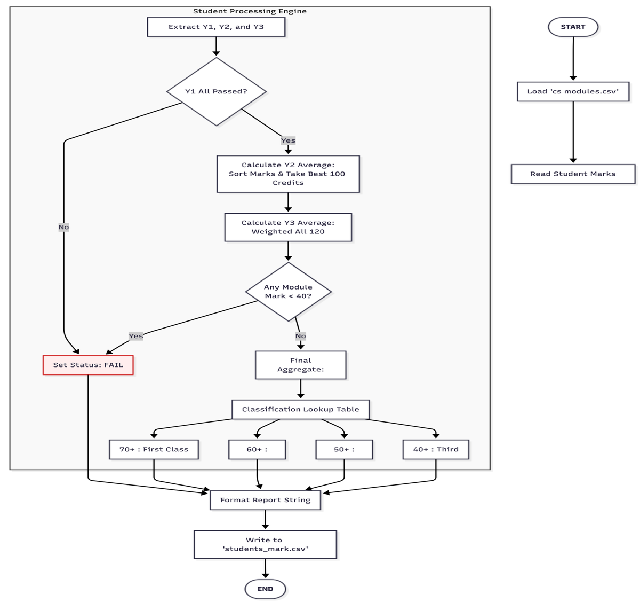
Figure 1 : Workflow diagram (AI-generated)

3. Password Generator

3.1 Data Structures
The main data structures are lists and integers. Lists store character sets — capital letters, lowercase letters, digits, and symbols — and construct passwords dynamically with constant-time access (O(1)). Integers track counts of each character type, enforcing constraints like maximum capitals or symbols (GeeksforGeeks, 2026).

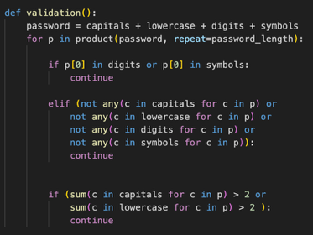
3.2 Algorithm Design
Recursive backtracking generates passwords of user-specified length while enforcing constraints: the first character must be a letter, all character types must appear at least once, and there is a maximum of two capital letters and two symbols. The algorithm prunes branches when constraints are violated. Completed passwords are indexed and exported to CSV.
As shown in Figure 2, the previous approach used Python’s built-in itertools library to generate all possible combinations and then filter out invalid passwords. The current design instead generates only valid passwords directly (Lee & Hubbard, 2024).
Figure 2

3.3 Justification
Lists allow flexible password construction, integers enforce rules efficiently, and direct valid password generation improves performance. Using recursive backtracking instead of generating all combinations reduces memory usage and computation time because invalid branches are discarded early.
4. Route Planning
4.1 Data Structures
The program uses a bidirectional graph stored as a dictionary of dictionaries, where each station is a key and neighbouring stations with travel costs are values. Python’s built-in heapq priority queue library selects the next station with the smallest cumulative cost efficiently. Lists and sets track user inputs and visited stations, a dictionary stores previous nodes, and distances from the start are maintained (GeeksforGeeks, 2026).
4.2 Algorithm Design
Station inputs are cleaned, formatted, and validated, including fuzzy matching to suggest close alternatives. The shortest path is computed using Dijkstra’s algorithm with a priority queue heapq (Algorithm 1), allowing repeated intermediate transit stations where necessary. Algorithm 2 presents the older version using naive minimum search. Full route planning iteratively selects the next station with the lowest immediate cost, appends path segments, avoids repeating the connecting station between consecutive segments, calculates total route cost, and saves the final path to a CSV file. Execution time is displayed for performance tracking (Lee & Hubbard, 2024).

Algorithm 1: Dijkstra with Priority Queue
Algorithm: Dijkstra_PriorityQueue(Graph, Start, End, AvoidStations)
- Initialise Distance for all nodes to infinity.
- Set Distance[Start] = 0.
- Initialise Previous = {} (empty dictionary).
- Initialise Heap as a priority queue containing (0, Start).
- Initialise Visited = {} (empty set).
While Heap is not empty do
a. Extract (CurrentDist, CurrentNode) from Heap with minimum value.
b. If CurrentNode is in Visited, continue.
c. Add CurrentNode to Visited.
d. If CurrentNode = End, break.
e. For each (Neighbour, Cost) in Graph[CurrentNode] do
i. If Neighbour is in Visited or Neighbour is in AvoidStations, continue.
ii. Set NewDist = CurrentDist + Cost.
iii. If NewDist < Distance[Neighbour], then:
- Set Distance[Neighbour] = NewDist
- Set Previous[Neighbour] = CurrentNode
- Add (NewDist, Neighbour) to Heap
- If Distance[End] = infinity, return empty path and infinity.
- Set Path = BuildPath(Start, End, Previous).
- Return Path, Distance[End].
_____________________________________________________________________________________________

Algorithm 2: Dijkstra with Naive Minimum Search
Algorithm Dijkstra_NaiveMin(Graph, Start, End)
- Initialize Distance for all nodes to infinity
- Distance[Start] = 0
- Previous = {} (empty dictionary)
- Visited = {} (empty set)
LOOP
a. CurrentNode = unvisited node with minimum Distance
b. IF CurrentNode == End OR no unvisited nodes THEN break
c. Add CurrentNode to Visited
FOR each (Neighbour, Cost) of CurrentNode DO
i. NewDist = Distance[CurrentNode] + Cost
ii. IF NewDist < Distance[Neighbour] THEN
- Distance[Neighbour] = NewDist
- Previous[Neighbour] = CurrentNode
- Path = BuildPath(Start, End, Previous)
- RETURN Path, Distance[End]

4.3 Justification
Dictionaries enable O(1) access to station data, while the priority queue is better than naive minimum search because it identifies the next station with the lowest cumulative cost more efficiently. Also,Fuzzy matching enhances robustness against input errors. Overall, the algorithm ensures accurate route construction and is efficient for handling rail network data.

5. Parallel Programming

5.1 Data Structures
The program uses lists and NumPy arrays for efficient image handling. Lists store all filenames and allow straightforward splitting into chunks. Matched filenames are collected via a multiprocessing.Queue, ensuring thread-safe append operations without conflicts. NumPy arrays represent faces as numerical feature vectors, enabling fast vectorized comparisons instead of slower Python list operations.

5.2 Algorithm Design
The algorithm encodes a known face and processes each unknown image to extract encodings. Filenames are divided into chunks based on CPU cores and processed in parallel with multiple processes. Each chunk’s matches are pushed to a shared queue. After all processes finish, matches are collected from the queue. Optionally, matched images can be displayed with rectangles drawn around detected faces using OpenCV. Execution time is measured to assess parallel performance (Python Software Foundation, 2025).

5.3 Justification
Chunking exploits parallelism, minimizing context switching. Using a queue allows safe, concurrent writes without race conditions. Lists and NumPy arrays provide flexible storage and fast vectorized computation. This design scales efficiently for large datasets and ensures robust, high-performance face recognition.

6. Conclusion
Efficient data structures and algorithms were applied across all activities, optimizing performance, scalability, and accuracy. Justifications highlight design choices, balancing speed, memory, and clarity, ensuring reliable, consistent, maintainable, and robust outputs for all activities across multiple use cases.

7. Reference List

GeeksforGeeks (2026) Python tutorial. [online] Available from: https://www.geeksforgeeks.org/python/python-programming-language-tutorial/ [Accessed 17 March 2026].

Lee, K.D. and Hubbard, S. (2024) Data Structures and Algorithms with Python with an Introduction to Multiprocessing [online]. 2nd ed. Springer Nature Switzerland Ag: Cham, Switzerland. [Accessed 15 February 2026].

Python Software Foundation (2025) multiprocessing — Process-based parallelism — Python 3.13 documentation. [online] Available from: https://docs.python.org/3/library/multiprocessing.html [Accessed 14 March 2026].

W3schools (2025) DSA Dijkstra’s Algorithm. [online] Available from: https://www.w3schools.com/dsa/dsa_algo_graphs_dijkstra.php [Accessed 1 March 2026].

